Available online at website: https://jurnal.iaii.or.id/index.php/RESTI
 | JURNAL RESTI  (Rekayasa Sistem dan Teknologi Informasi)
 | Vol. x No. x (2024) xx - xx | e-ISSN: 2580-0760

Comparative Analysis of CNN Architectures and Optimizers for ALL Classification

Abstract
Recent advances in deep learning, particularly Convolutional Neural Networks (CNNs), have significantly improved image classification performance in medical imaging. However, CNN effectiveness depends not only on network architecture but also on the optimization algorithms used during training. This study examines the impact of different optimizers on the performance of multiple CNN architectures for classifying Peripheral Blood Smear (PBS) images. A Kaggle dataset containing 3,242 images across four classes was utilized. Six CNN models ResNet50V2, Xception, EfficientNetB2, EfficientNetB4, EfficientNetV2-S, and EfficientNetV2-M were trained using four optimizers: Adam, AdamW, NAdam, and RMSprop. Image preprocessing included resizing, normalization, and extensive data augmentation. The dataset was split into training, validation, and testing sets with an 80:10:10 ratio. Model performance was evaluated using accuracy, loss, and confusion matrices. Experimental results reveal that the Xception model combined with RMSprop achieved the highest performance, reaching an accuracy of 99.69% with a loss of 0.0194. In contrast, ResNet50V2 showed the weakest performance, particularly with RMSprop, achieving only 93.85% accuracy. These findings demonstrate that optimizer selection plays a crucial role in CNN-based image classification and its effectiveness varies across architectures.

Keywords: Deep Learning; CNN; Optimizer; Xception; RMSProp

How to Cite: [Caption completed by the editor]
Permalink/DOI: [Caption completed by the editor]

Received: [Caption completed by the editor]  Accepted: [Caption completed by the editor]  Available Online: [Caption completed by the editor] | This is an open-access article under the CC BY 4.0 License  Published by Ikatan Ahli Informatika Indonesia

- Introduction
The rapid development of deep learning in recent years has had a significant impact on various areas of computing, especially computer vision [1]. Deep learning enables computational models to autonomously extract intricate representations from large-scale data, eliminating reliance on handcrafted feature design [2], [3]. This capability makes deep learning the dominant approach in various image processing tasks, such as classification, object detection, and image segmentation, with performance that consistently exceeds conventional machine learning methods [4], [5].
One of the most influential deep learning architectures in the field of image processing is the Convolutional Neural Network (CNN) [6]. CNN is designed to handle grid-shaped data, such as two-dimensional imagery, through convolution, pooling, and non-linear activation mechanisms [7]. CNNs learn visual representations in a layered manner, where early layers capture basic patterns while deeper layers encode more abstract and object-related information [8]. This advantage makes CNN the main foundation in the development of modern image classification systems [9].
As the complexity of data increases and the demands for high accuracy increase, a range of deeper and more efficient CNN architectures have been developed [10]. ResNet introduced the concept of residual learning that allows for deep network training by overcoming the vanishing gradient problem [11]. Furthermore, Xception utilizes depthwise separable convolution to improve computing efficiency without sacrificing performance [12]. The EfficientNet family [13], including EfficientNetB2 and EfficientNetB4, carries a compound scaling strategy that systematically adjusts the depth, network width, and resolution of inputs resulting in optimal efficiency and accuracy ratios [14]. Subsequent developments on EfficientNetV2, such as EfficientNetV2-M and EfficientNetV2-S, focused on training speed and convergence stability, particularly on large and complex datasets [15].
In addition to architecture selectors, optimizers have a crucial role in the CNN training process [16]. Optimization algorithms control the adjustment of network parameters by guiding learning through error gradients, thereby influencing convergence behavior, robustness during training, and the model’s ability to perform well on unseen data [17]. Some optimizers that are often used in deep learning are Adam, AdamW, NAdam, and RMSprop [18]. Adaptive optimizers like Adam are widely used because of their ability to combine momentum and automatic learning rate adjustments [19]. AdamW was developed to fix Adam's weaknesses by separating the weight decay mechanism from gradient updates thus improving the generalization of the model [20]. Meanwhile, NAdam integrates Nesterov's momentum into Adam's framework, and RMSprop adjusts the learning rate based on the previous average of the gradient squares to maintain learning stability [21]. Although each optimizer has been proven to be effective, its performance is highly dependent on the CNN architecture and the characteristics of the dataset used [22].
In the classification of medical images, the challenges faced are often more complex than natural images due to the characteristics of medical data influenced by acquisition protocols, domain variations, label limitations, and noise or imperfect label issues [23]. In addition, medical imaging (especially histopathology/hematology) often experiences variations in imaging conditions such as differences in staining and shift domains between centers/tools, which makes model generalization more difficult [24]. The problem of class imbalance is also common in the classification of medical images and has been proven to need special treatment so that the performance of the minority class does not fall [25]. LLA (Acute Lymphoblastic Leukemia or acute lymphoblastic leukemia) itself is a hematological malignancy that requires a quick and accurate diagnosis to increase the success of therapy [26]. Deep learning-based approaches promise automation solutions that can handle such diversity and complexity better than conventional analytics [23]. Therefore, a systematic evaluation of the combination of CNN architecture and optimizer is critical to obtaining optimal performance and reliable models in clinical practice.
Several previous studies have applied CNN to the detection and classification of leukemia from microscopic blood imaging. Jeneessha et al. [27], demonstrating CNN's ability to distinguish very fine differences in blood cell morphology, they reported an average accuracy of 99.05% using ResNet-50 for the classification of 4 leukocyte types in the BCCD dataset, confirming the advantages of deep learning over traditional methods. However, very high accuracy figures on curated datasets also need to be read carefully (potential for data leakage or split that are not patient-based), so studies that emphasize rigorous validation remain important. In the case of ALL, various modern architectures have been tried. Thiriveedhi et al. [28] developed a CNN-based ALL-Net model and explainable AI, which achieved an accuracy of about 97.85% on 3,256 peripheral blood images. Abd El-Aziz et al. [29] using EfficientNetV2-S with a cross-validation scheme, it managed to obtain an accuracy of up to ~97.3% in differentiating ALL cells. Ghaderzadeh et al. [30] built a public ALL dataset containing ~3,562 blood-removal images from 89 patients (including 25 healthy individuals), and trained a variety of pretrained models; DenseNet201 is reported to achieve up to 99.85% accuracy (99.52% sensitivity, 99.89% specificity) on the ALL subtype classification task. In addition, Muduli et al. [31] evaluate a diverse range of pretrained CNN models (VGG16, ResNet50, Xception, EfficientNet-B0/V2B0, etc.) for ALL classification and demonstrate the high potential of modern CNN in this task. Mohan et al. [32] propose an ensemble framework that combines deep learning features (DenseNet-121, ResNet-34) with machine learning classifiers (SVM, K-NN, Random Forest), capable of improving accuracy by up to ~92.5% (F1-score 93.1%) on larger ALL C-NMC datasets. Although various architectures and approaches have been successfully applied, to date there have been no studies that specifically compare the influence of several optimizers (e.g. Adam, AdamW, NAdam, RMSprop) on the performance of cutting-edge CNN models such as EfficientNet and ResNet in the ALL classification.
Based on the above problems and knowledge gaps, this study aims to evaluate and compare the performance of four optimizers (Adam, AdamW, NAdam, RMSprop) on various CNN architectures (EfficientNet-B2, EfficientNet-B4, EfficientNetV2-S, EfficientNetV2-M, ResNet50V2, and Xception) in the task of classifying blood cell microscopic images for ALL detection. We used an ALL public dataset [33] of 3,256 colored blood cell images from 89 patients (four classes), and conducted in-depth training experiments for each combination of architecture and optimizer. The results obtained are expected to provide empirical insight into which combination of CNN architecture and optimizer is most effective for the classification of ALL, so that it can serve as a reference for the development of a more accurate and efficient computer-aided diagnostic system in supporting the diagnosis of acute lymphoblastic leukemia.

Methods
The research was carried out through four main stages, namely data collection, data preprocessing, model training, and model evaluation. Each stage is systematically designed to ensure that the experimental process is structured, consistent, and replicable, so that the results obtained can be analyzed objectively. Figure 1 illustrates the flow of the research methods used in this study.
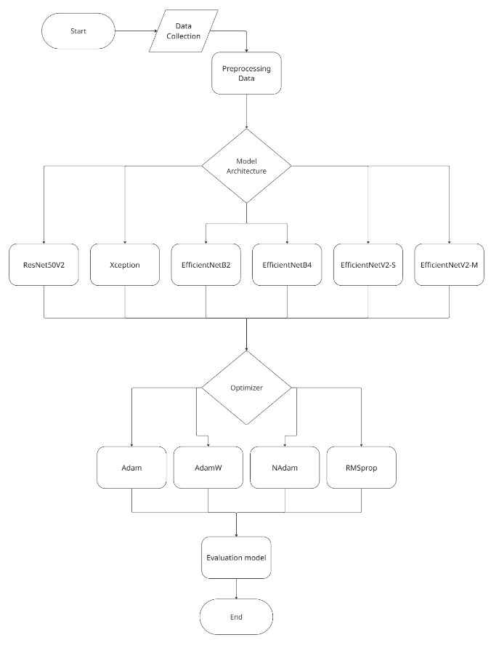
Figure 1. Flowchart
2.1 Dataset
The dataset used in this study is in the form of a Peripheral Blood Smear (PBS) from patients with suspected Acute Lymphoblastic Leukemia (ALL). This dataset is obtained from Kaggle with https://www.kaggle.com/datasets/mohammadamireshraghi/blood-cell-cancer-all-4class link. This dataset consists of 3,242 PBS images and is divided into four classes based on the condition and stage of malignancy of blood cells. The Benign class (normal cells) amounted to 512 images, Malignant Early Pre-B as many as 955 images, Malignant Pre-B as many as 796 images, and Malignant Pro-B as many as 979 images. Thus, the total number of images in this dataset is 3,242 images, which are used for the training and evaluation process of classification models in distinguishing normal blood cells and leukemia cells based on their morphological characteristics.
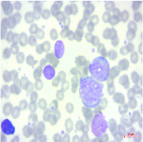 | 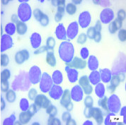 | 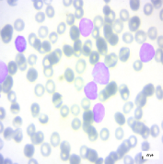 | 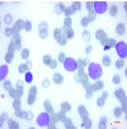
(a) | (b) | (c) | (d)
Figure 2. Dataset Kelas ALL (a) Benign, (b)Malignant Pre-B ALL, (c) Malignant Pro-B ALL, (d) Malignant Early Pre-B ALL

  - Preprocessing dan Split Dataset
Preprocessing is the initial stage in medical image processing that aims to improve data quality, reduce irrelevant variations, and prepare images in an appropriate format before the deep learning model training process [34]. In this study, preprocessing is focused on adjusting the image size to standardize the input dimensions according to the needs of each CNN architecture, namely EfficientNetB2, EfficientNetB4, EfficientNetV2-M, EfficientNetV2-S, ResNet50V2, and Xception. The image resizing process is carried out to ensure the compatibility of the model inputs, reduce the computational burden, and maintain important morphological information on blood cell images, which is crucial in the task of classifying medical images. To ensure accurate model evaluation and avoid overfitting, the medical imagery dataset is divided into three parts: training: validation: test, 80:10:10. This strategy allows monitoring of model performance during training while evaluating generalization capabilities against unknown data, as applied in a chest image classification study with CNN [35].
  - Augmentation
The data augmentation stage is carried out to increase the diversity of training data by applying various transformations to the original image without changing its class label [35]. Data augmentation aims to reduce the risk of overfitting and improve the generalization ability of the model, especially in medical image datasets that generally have a limited amount of data. In this study, augmentation was applied using geometric transformations, including rotation range, width shift range, height shift range, shear range, zoom range, horizontal flip, and fill mode.

  - Model CNN
Convolutional Neural Network (CNN) is one of the artificial neural network architectures that is specifically designed to process two-dimensional image data [36]. Conventional CNN is generally built using a sequential approach consisting of several main layers, namely convolution layers to extract local spatial features, pooling layers to reduce computational dimensions and complexity, and fully connected layers that function as classifiers based on the features that have been studied. Conventional CNN architecture is often used as a baseline model in medical image classification research due to its simple structure but effective in studying hierarchical representations of visual features. Examples of some CNN architecture models that will be used in this study are:
    - EfficientNetB2
EfficientNetB2 is one variant of the EfficientNet family, which is a Convolutional Neural Network (CNN) architecture designed with a compound scaling approach to systematically balance network depth, network width, and input resolution [37]. The compound scaling approach allows for a proportional increase in model capacity across all three dimensions, resulting in better classification performance with relatively efficient computing requirements. This strategy enables EfficientNetB2 to achieve high accuracy with a lower number of parameters than conventional CNN architectures and unstructured magnified models.
    - EfficientNetB4
EfficientNetB4 is one variant of the EfficientNet family that was developed by applying a compound scaling strategy to balance network depth, network width, and input resolution in a coordinated manner [37]. Compared to EfficientNetB2, EfficientNetB4 has a larger model capacity through proportional enhancement of all three dimensions, thus being able to extract more complex visual features. Despite having a higher number of parameters and computing requirements, EfficientNetB4 still maintains good computing efficiency and shows significant improvements in accuracy, especially on high-complexity image classification tasks, including medical imaging.
    - EfficientNetV2-S
EfficientNetV2-S is a small variant of the EfficientNetV2 family of architectures designed to strike a balance between computational efficiency and classification accuracy [38]. The EfficientNetV2 architecture introduces the use of Fused Mobile Inverted Bottleneck Convolution (Fused-MBConv) at the initial layer of the network and MBConv at the deeper layers, thereby reducing training latency and improving convergence stability. As a smaller variant than EfficientNetV2-M, EfficientNetV2-S has a lower number of parameters and computational complexity, making it suitable for training on medium-sized datasets as well as compute environments with limited resources, without sacrificing feature extraction capabilities that are essential for image classification tasks.
    - EfficientNetV2-M
EfficientNetV2-M is one variant of the EfficientNetV2 family that was developed to improve training speed and convergence stability without sacrificing model accuracy [38]. The EfficientNetV2 architecture combines the use of fused mobile inverted bottleneck convolution (Fused-MBConv) at the initial layer and MBConv at the deeper layers, reducing training latency while maintaining robust feature extraction capabilities. As a medium-scale variant, EfficientNetV2-M has a larger model capacity than EfficientNetV2-S, making it more effective in handling large and complex datasets, including medical image classification tasks that require rich and detailed feature representation.
    - ResNet50V2
ResNet50V2 is a variant of the Convolutional Neural Network (CNN) architecture that is an evolution of ResNet50 with improvements to residual learning, specifically through the use of pre-activation residual blocks that move activation functions and batch normalization prior to convolutional operations [39]. This approach helps reduce vanishing gradient issues and improve learning stability in very deep networks, allowing models to learn more complex visual feature representations with better performance on a variety of image classification tasks. The ResNet50V2 is widely used in a wide range of image processing applications, including the diagnosis of medical diseases through radiographic imagery due to its ability to extract an informative feature hierarchy.
    - Xception
Xception is a CNN architecture that relies on depthwise separable convolution as its main building, i.e. the separation of convolution operations into depthwise convolution and pointwise convolution (1×1 convolution) to combine channels [40]. This approach significantly reduces the number of parameters and computational load while maintaining or even improving representational capabilities over standard convolution; Xception also utilizes residual structures to smooth gradient flow in deep tissues. Due to its efficiency and performance, Xception is often used as the basis or starting point for modifications to medical image classification applications.
  - Optimizer
An optimizer is an algorithm used in neural network training to update the weights of the model based on the loss function gradient calculated through backpropagation. The main goal of the optimizer is to find a weight value that minimizes the loss value, so that the model's ability to map features to the target label is optimal. In this study, several optimizers were used for model training, namely Adam, AdamW, NAdam, and RMSprop optimizers.
    - Adam
Adam is an adaptive and efficient optimization algorithm, often used as an alternative to conventional stochastic gradient descent [41]. This algorithm combines RMSProp and momentum, with momentum from the first moment of the biased gradient and the second moment calculated using an exponential moving average, with the following formulation [42].
Counting the first moment
$$m_{t}=β_{1}m_{t-1}+(1-β_{1})g_{t}$$ | (1)

Calculating the second moment
$$v_{t}=β_{2}v_{t-1}+(1-β_{2})g_{t}^{2}$$ | (2)
Because $m_{0}=0$ and $v_{0}=0$ , the value $m_{t}$ and $v_{t}$ at the beginning tends to be biased near zero. So the bias correction is made:
$${\hat{m}}_{t}=\frac{m_{t}}{1-β_{1}^{t}}$$ | (3)
$${\hat{v}}_{t}=\frac{v_{t}}{1-β_{2}^{t}}$$ | (4)

The parameters are then updated using:
$${\hat{θ}}_{t}=θ_{t-1}-α\frac{{\hat{m}}_{t}}{\sqrt{\hat{v}}+ϵ}$$ | (5)

Where $θ_{t}$ is the parameter of the model in the iteration, is the learning rate, ${\hat{m}}_{t}$ provides a stable direction (momentum), $\sqrt{{\hat{v}}_{t}}$ determines the magnitude of the step, and $ϵ$ is a small constant.
    - AdamW
Momentum-based optimizers such as AdamW have an inertial pattern on the gradient so that it can accelerate convergence [43].
Counting the first moment
$$m_{t}=β_{1}m_{t-1}+(1-β_{1})g_{t}$$ | (6)

Calculating the second moment
$$v_{t}=β_{2}v_{t-1}+(1-β_{2})g_{t}^{2}$$ | (7)
Bias correction with

$$m_{t}←\frac{m_{t}}{α_{1}μ_{t}}$$ | (8)
$$v_{t}←\frac{v_{t}-m_{t}^{2}}{α_{2}σ_{t}}$$ | (9)
The update of the AdamW parameter uses a form of decoupled weight decay, namely:
$$θ_{t+1}=θ_{t}-η\frac{m_{t}}{\sqrt{v_{t}}+ε}-ηλθ_{t}$$ | (10)
Where $θ_{t}$ is the parameter of the model, $η$ is the learning rate, $m_{t}$ is the average momentum of the gradient, $v_{t}$ is the mean of the square of the gradient, $ε$ is the small value, and $λ$ is the weight decay.
    - NAdam
NAdam is an adaptive optimizer that predicts combining Nesterov momentum with an adaptive learning rate adjustment scheme like Adam, and allows parameter updates that pass-through gradients [44]. Mathematically, Nadam updated the first Moment
$$m_{t}=μ_{t}m_{t-1}+\left(1-μ_{t}\right)g_{t}$$ | (11)
Second moment
$$n_{t}=vn_{t-1}+\left(1-v\right)g_{t}^{2}$$ | (12)
Then correct the bias by updating the parameters as follows.
$$θ_{t}=θ_{t-1}-α_{t}\frac{{\hat{n}}_{t}}{\sqrt{{\hat{n}}_{t}}+ε}\hat{m}$$ | (13)
Where $g_{t}$ is the gradient, $m_{t}$ is the momentum estimate, $n_{t}$ is the second moment estimate, ${\hat{n}}_{t}$ is the bias correction, $α_{t}$ is the learning rate, and $ε$ is the constanta.
    - RMSProp
RMSProp is an adaptive optimization algorithm designed to solve the problem of vanishing or fluctuating learning rate in SGD [45]. In RMSProp, the learning rate value of each parameter is adjusted based on the moving average of the gradient square. In this way, parameters that often result in large gradients will get smaller update steps, while parameters with small gradients will have larger update steps so that the learning process becomes more stable. RMSprop has two basic mechanisms, namely:
Mean Squared Gradient
$$v_{t}=βv_{t-1}+\left(1-β\right)g_{t}^{2}$$ | (14)
Where $v_{t}$ is the mean value of the square of the gradient, $β$ is the coefficient, $v_{t-1}$ is the mean value of the square of the gradient in the previous step, and $g_{t}^{2}$ is the gradient square.
Weight update
$$w_{t+1}=w_{t}-\frac{η}{\sqrt{v_{t}}+ε}g_{t}$$ | (15)
Where $w_{t}$ is the weight of the model, $w_{t+1}$is the weight that has been updated, $η$ is the learning rate, $v_{t}$ is the average value of the square of the gradient, $ε$ is the small value to prevent division by zero, $g_{t}$ is the gradient, and $\frac{η}{\sqrt{v_{t}}+ε}$ is the adjustment factor to be stable when the gradient is large or small.
  - Evaluasi
Evaluation is a process to measure the performance of a classification model by comparing the model's prediction results with the actual label with the aim of finding out how well the model predicts and determining whether the model is good enough or needs improvement [46]. Evaluation has an important selection of matrices when the data is unbalanced because the matrices that measure performance are different and can overlap. Evaluation uses a confusion matrix to obtain accuracy, precision, recall and F1-score. The four components of the confusion matrix are False Positive (FP), False Negative (FN), True Positive (TP), and True Negative (TN) [47].
$$Accuracy=\frac{TP+TN}{TP+FP+FN+TN}$$ | (16)
$${Precision}_{i}=\frac{{TP}_{i}}{{TP}_{i}+{FP}_{i}}$$ | (17)
$${Recall}_{i}=\frac{{TP}_{i}}{{TP}_{i}+{FN}_{i}}$$ | (18)
$${F1}_{i}=2\frac{{Precision}_{i}∙{Recall}_{i}}{{Precision}_{i}+{Recall}_{i}}$$ | (19)

3. Results and Discussions
This section presents the results of the experiment along with a critical discussion regarding the influence of optimizer selection on the performance of various CNN architectures on image classification tasks. To maintain the validity of the interpretation, the discussion begins with a description of Technical Implementation and Reproducibility, so that the experimental procedures, training parameters, and computing environment can be replicated. After that, the Preprocessing Results were presented to show how the data sharing and augmentation strategies shaped the characteristics of the training data as well as the potential bias due to class imbalance. The discussion then focused on CNN Performance Evaluation, by comparing the overall performance of the model through accuracy, convergence dynamics on the training curve, and error patterns per class through confusion matrix and classification report.
3.1 Technical Implementation and Reproducibility
All experiments were implemented on Google Colab using NVIDIA T4 GPU acceleration to ensure that the model training process was efficient and consistent between configurations. Implementation was carried out with PyTorch as the main framework of deep learning, while the CNN architecture was invoked through timms (PyTorch Image Models) to load models such as Xception, ResNet50V2, EfficientNetB2, EfficientNetB4, EfficientNetV2-RW-S, and EfficientNetV2-RW-M. The quantitative evaluation process utilizes scikit-learn for the preparation of confusion matrix and classification reports, as well as visualization of training and evaluation results using Matplotlib/Seaborn. The dataset is obtained via the Kaggle API/CLI and organized in a uniform directory structure so that the notebook execution flow can be rerun without major modifications to the data path.
The experimental design was designed to make comparisons between optimizers fair, i.e. by maintaining the same training procedures on each architecture, and then replacing only the optimizers tested (Adam, AdamW, NAdam, RMSprop). The training used the CrossEntropyLoss loss function for multi-class classification and applied a two-stage learning transfer scheme: the initial stage of training the classifier/head with a learning rate of 0.001 for 10 epochs, then continued with full fine-tuning on all model parameters with a learning rate of 0.00001 for 10 epochs. To maintain convergence stability, adaptive learning rate adjustment is implemented using ReduceLROnPlateau which monitors validation loss so that the learning rate is lowered when validation performance improvements slow down.
The reproducibility aspect is maintained through locking the data composition using train: validation:test = 80%: 10%: 10% separation with a deterministic generator (seed 42) in the split process, as well as training configurations that are maintained identical across optimizer architecture combinations. The best model per configuration is stored in a validation performance-based state_dict (.pth) format so that results can be re-verified without retraining. The final evaluation was carried out on the test set using accuracy and error analysis per class through confusion matrix and classification report, while learning dynamics were documented through training history (loss and accuracy train or val per epoch) to support convergence interpretation, generalization, and comparison between optimizers more comprehensively.
  - Preprocessing Result
The preprocessing stage is carried out to ensure that the image data has a consistent input format across the CNN architecture and to build a more robust training dataset through augmentation. At this stage, the dataset is first mapped into four classes (Benign, [Malignant] Pre-B, [Malignant] Pro-B, and [Malignant] early Pre-B), then divided into a subset of training/validation/testing with a ratio of 80%: 10%: 10%. The data distribution table in Table 1 shows the composition of each class in each subset. There is an imbalance in the number of samples between classes, especially the Benign class which has the least number of samples. This condition needs to be considered at the evaluation stage because it can affect the interpretation of aggregate metrics such as accuracy.
Table 1. Results of Split Datasets
Kelas | Training | Validation | Testing | Total
Benign | 414 | 60 | 38 | 512
Pre-B ALL | 762 | 89 | 104 | 955
Pro-B ALL | 635 | 88 | 73 | 796
Early Pre-B ALL | 782 | 87 | 110 | 979
Total | 2593 | 324 | 325 | 3242

To maintain input compatibility across different architectures, the image is then resized to the standard input size of each model Table 2 This approach ensures that comparisons between architecture and optimizer are performed under input conditions consistent with common architecture design and transfer learning practices (e.g., ResNet based 224×224, Xception 299×299, and the EfficientNet B/V2 family, which generally uses higher resolutions). With consistent input size settings per architecture, observed performance differences can more easily be attributed to architectural and optimizer characteristics than input resolution mismatches.

Table 2. Input size of each CNN architecture
Arsitektur | Ukuran input (H×W)
ResNet50V2 | 224×224
Xception | 299×299
EfficientNetB2 | 260×260
EfficientNetB4 | 320×320
EfficientNetV2- S | 320×320
EfficientNetV2-M | 320×320

In addition, data enrichment procedures were exclusively implemented on the learning subset through the torchvision. transforms framework to increase data diversity and mitigate overfitting. According to the implemented pipeline, each image was initially upscaled slightly to accommodate subsequent transformations, followed by stochastic operations including horizontal flipping with a probability of 0.5, vertical flipping with a probability of 0.2, random rotations within ±15 degrees, and affine transformations involving translations of up to 10% and scaling factors ranging between 0.9 and 1.1, without introducing extra rotation. Variations in illumination and color properties were further emulated using color perturbation techniques that adjust brightness, contrast, saturation, and hue within controlled ranges.
Subsequently, the processed images were restored to the required network input resolution, transformed into tensor representations, and standardized based on dataset-specific statistical parameters. Figure 2 illustrates representative outputs of this procedure, displaying one reference image alongside eight distinct, randomly generated transformed versions. The presence of dark regions in some samples originates from geometric operations that expose peripheral areas beyond the original field of view. Such transformations encourage the network to acquire feature representations that remain robust under changes in orientation, spatial positioning, and visual appearance, thereby preventing over-reliance on fixed visual patterns present in the training samples.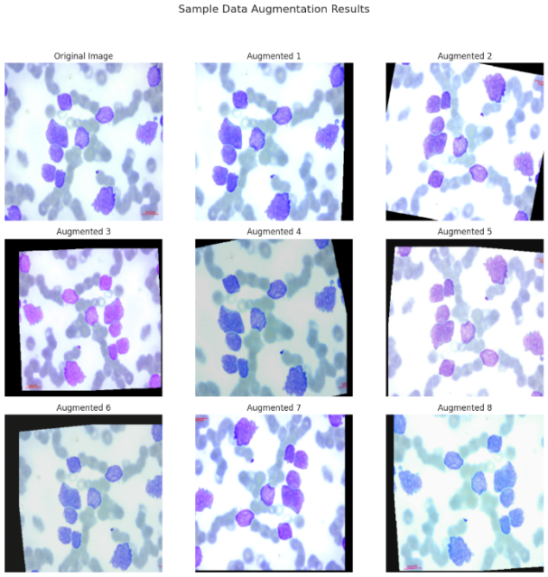
Figure 3. Data Augmentation Examples

  - CNN Model Performance
This section presents a comparative evaluation of the performance of six CNN architectures (Xception, ResNet50V2, EfficientNetB2, EfficientNetB4, EfficientNetV2-S, EfficientNetV2-M) using four optimizers (Adam, AdamW, NAdam, RMSprop) on the same test data. Performance is summarized through accuracy and cross-entropy loss in the test set (Table 3) as a concise indicator of prediction accuracy and probability quality of model output. To ensure that interpretation does not stop at aggregate numbers, the analysis is then complemented by a confusion matrix to review patterns of misclassification between classes, as well as classification reports per class that display precision, recall, and F1-score so that the strengths and weaknesses of the model can be understood more granularly, especially under unbalanced class distribution conditions.
Table 3. Comparison of test accuracy and test loss
Architecture | Adam |  | AdamW |  | NAdam |  | RMSProp
Architecture | Acc | Loss | Acc | Loss | Acc | Loss | Acc | Loss
ResNet50V2 | 0.9600 | 0.1593 | 0.9538 | 0.1581 | 0.9569 | 0.1863 | 0.9384 | 0.2023
Xception | 0.9877 | 0.0294 | 0.9939 | 0.0215 | 0.9908 | 0.0399 | 0.9969 | 0.0194
EfficientNetB2 | 0.9785 | 0.0643 | 0.9754 | 0.0878 | 0.9815 | 0.0634 | 0.9661 | 0.0702
EfficientNetB4 | 0.9877 | 0.0354 | 0.9908 | 0.0458 | 0.9908 | 0.0429 | 0.9877 | 0.0632
EfficientNetV2- S | 0.9846 | 0.0387 | 0.9754 | 0.0880 | 0.9908 | 0.0483 | 0.9723 | 0.0664
EfficientNetV2-M | 0.9908 | 0.0339 | 0.9877 | 0.0324 | 0.9877 | 0.0348 | 0.9877 | 0.0373

In general, the combination of Xception + RMSprop provides the best performance with an accuracy of 99.69% and a low loss of 0.0194, indicating highly accurate predictions and a more "certain" probability of output (low loss). On the other hand, ResNet50V2 tends to produce worse accuracy and losses than other architectures across all optimizers, with the most significant decline in RMSprop (93.85%; loss 0.2023). These findings show that differences in architecture and optimizers not only change the accuracy figures, but also affect the stability of optimization and the quality of prediction calibration (reflected in loss).
If you look at the optimizer section, NAdam shows very competitive performance on EfficientNetV2 architectures (e.g. EfficientNetV2-M and EfficientNetV2-S), while AdamW appears to be stable on some large architectures (e.g. Xception and EfficientNetB4). RMSprop is more "context-sensitive", it can be best on Xception, but it drops performance quite a bit on ResNet50V2 and EfficientNetV2-M. This pattern is important because it prevents overly general conclusions such as "a particular optimizer is always best", in fact, the effect of a strong optimizer is influenced by the architectural characteristics and dynamics of the gradient during fine-tuning.
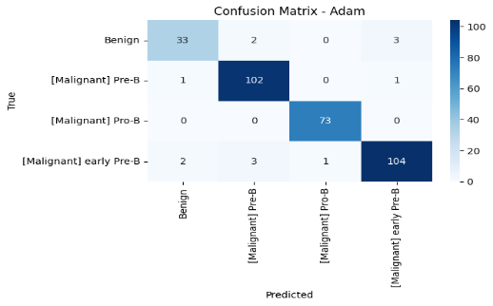
a. Adam ResNet50V2
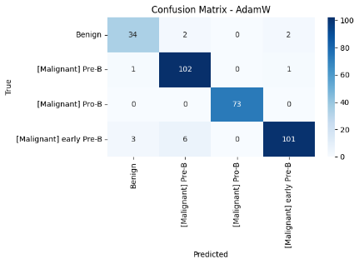
b. AdamW ResNet50V2
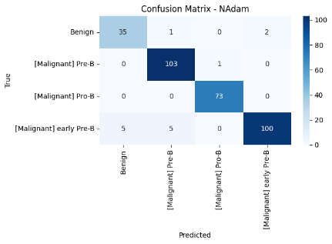
c. NAdam ResNet50V2
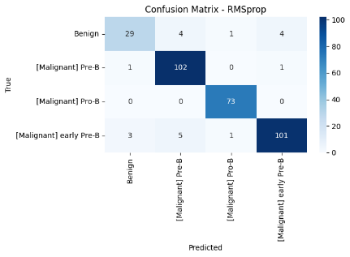
d. RMSprop ResNet50V2
Figure 4. Confusion Matrix ResNet50V2

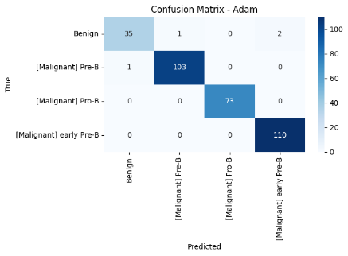
- Adam Xception
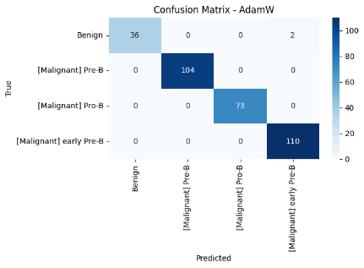
- AdamW Xception
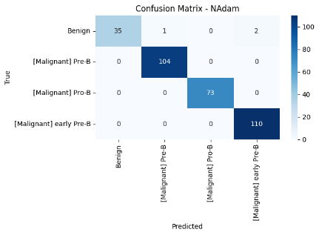
- NAdam Xception
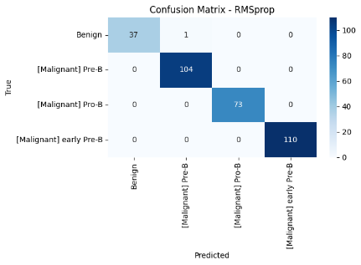
- RMSprop Xception
Figure 5. Confusion Matrix Xception

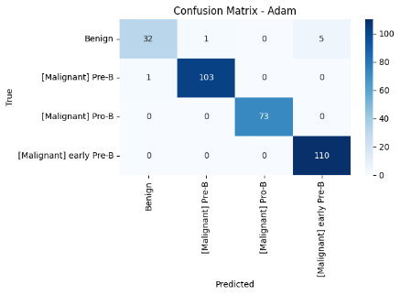
- Adam EfficientNetB2
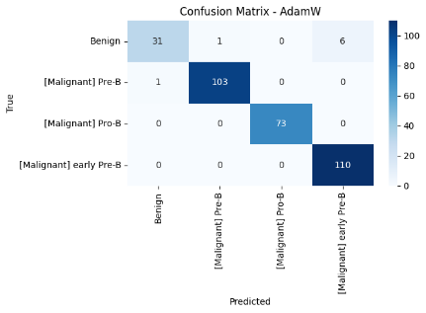
- AdamW EfficientNetB2
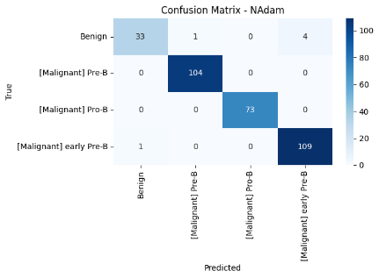
- NAdam EfficienNetB2
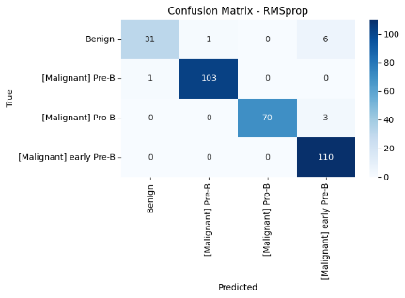
- RMSprop EfficientNetB2
Figure 6. Confusion Matrix EfficientNetB2

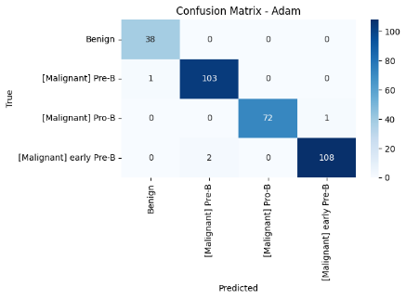
- Adam EfficientNetB4
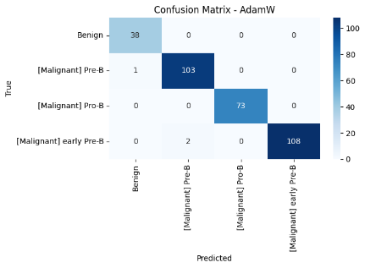
- AdamW EfficientNetB4
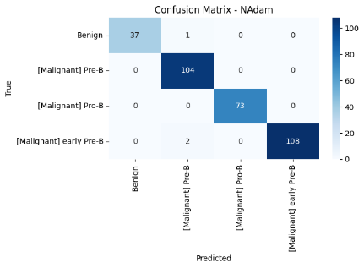
- NAdam EfficientNetB4
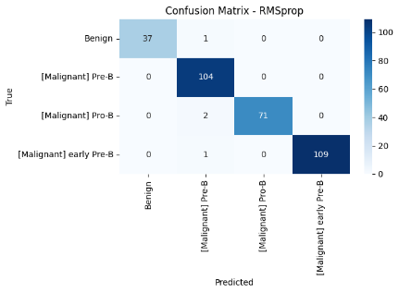
- RMSprop EfficientNetB4
Figure 7. Confusion Matrix EfficientNetB4

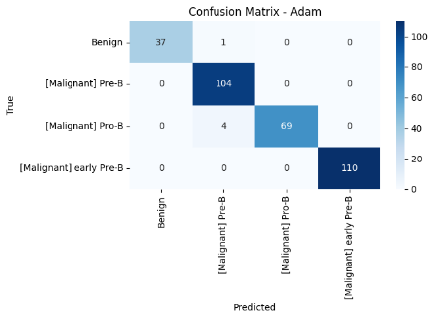
- Adam EfficientNetV2-S
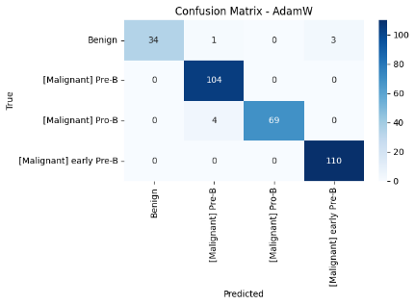
- AdamW EfficientNetV2-S
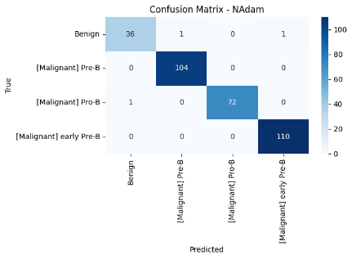
- NAdam EfficientNetV2-S
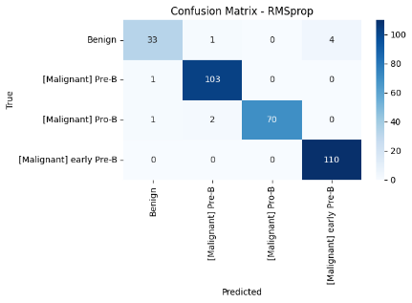
- RMSprop EfficientNetV2-S
Figure 8. Confusion Matrix EfficienNetV2-S

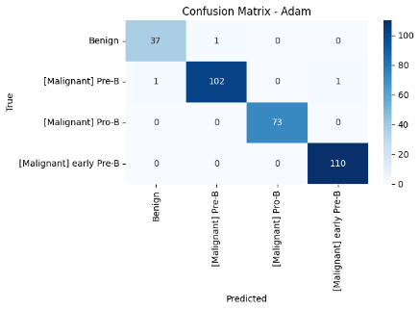
- Adam EfficientNetV2-M
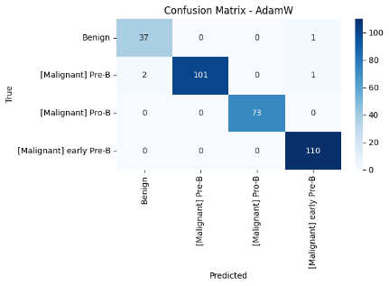
- AdamW EfficientNetV2-M
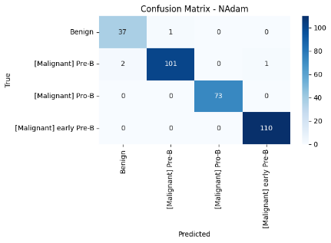
- NAdam EfficientNetV2-M
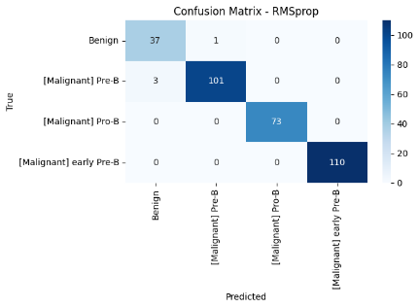
- RMSprop EfficientNetV2-M
Figure 9. Confusion Matrix EfficientNetV2-M

To clarify the source of the model's success and failure, a confusion matrix is displayed for each combination of architecture and optimizer in Figure 4-9. A "good" matrix will show the dominance of the value on the main diagonal, which means that most of the sample is predicted to be correct according to its class. In very high-accuracy configurations (e.g. Xception + RMSprop), the error that occurs is generally only 1 to 2 samples on the test set so the off-diagonal is very small. In contrast, in configurations with lower accuracy (e.g. ResNet50V2 + RMSprop), the off-diagonal becomes more prominent, indicating an increase in misclassification between classes. Confusion matrix analysis is also important because aggregate accuracy can mask problems in minority classes, if classes like Benign are much fewer, then a small number of errors in those classes can have a big impact on minority class recalls even though the total accuracy is still high.
The error patterns observed in the confusion matrices can be further explained through the interaction between the optimizer and network architecture, particularly in the case of RMSprop. The pronounced performance disparity of RMSprop between ResNet50V2 and Xception can be hypothesized to stem from the interaction between RMSprop’s adaptive learning rate mechanism and the residual connection characteristics of the ResNet architecture. RMSprop adjusts the learning rate of each parameter based on the exponentially decaying moving average of squared gradients, causing parameters with high gradient variance to receive smaller update steps.
In the ResNet50V2 architecture, which relies heavily on identity-based residual connections to preserve gradient flow in deep networks, this adaptive mechanism may inadvertently attenuate the contribution of gradients along the residual branches, especially during the fine-tuning stage with a relatively small learning rate. As a result, weight adaptation in deeper layers becomes less optimal, preventing feature representations from fully adapting to the characteristics of the new data, which in turn leads to higher loss values and reduced accuracy.
In contrast, Xception does not rely on deep identity residual connections, but instead employs depthwise separable convolutions that explicitly decouple spatial and channel-wise modeling. This design tends to produce more stable and localized gradient distributions across blocks, making it more compatible with RMSprop’s parameter update strategy. Under these conditions, adaptive learning rate adjustment facilitates faster convergence and improved generalization performance, as reflected by higher accuracy and lower loss values. Therefore, the observed performance degradation of ResNet50V2 when using RMSprop is not merely empirical, but is likely influenced by a mismatch between RMSprop’s optimization dynamics and the residual-dominated structure of the ResNet architecture, particularly in transfer learning–based fine-tuning scenarios.

4. Conclusions
Analysis of the experimental outcomes demonstrates that the pairing between network architecture and optimization strategy plays a decisive role in determining classification effectiveness for ALL images. Among the evaluated configurations, the Xception network optimized with RMSprop achieved the most favorable outcomes, as reflected by superior predictive accuracy and minimal error values. Conversely, ResNet50V2 exhibited comparatively weaker behavior across multiple optimization settings, with the most pronounced performance decline observed when RMSprop was employed. These discrepancies across configurations indicate that a universally optimal optimizer does not exist; rather, optimization success is closely linked to the structural properties of the network and its learning dynamics. The objectives of this work are therefore fulfilled by clearly illustrating performance distinctions across architecture optimizer pairings and emphasizing the necessity of carefully selecting model configurations to achieve reliable classification results.
The optimal configuration identified in this work, namely Xception combined with RMSprop, carries meaningful implications for the design of automated medical image analysis systems. Deploying this configuration may enhance the robustness and predictive reliability of computer-assisted frameworks for ALL detection, thereby strengthening their ability to support clinical decision-making processes. More broadly, these findings offer practical insights for both researchers and practitioners when choosing suitable CNN structures alongside effective optimization strategies for related image classification problems. Recognizing that predictive capability is sensitive to training design allows system developers to better align model choices with the intrinsic characteristics of medical image data, ultimately enabling the construction of efficient and dependable diagnostic support systems for clinical use.
Despite these contributions, several constraints should be acknowledged. The experimental validation relied on a single publicly available dataset with restricted sample size and variability, which may limit the direct transferability of the results to real-world clinical settings. Furthermore, the investigation was confined to six network designs and four optimization algorithms, leaving open the possibility that alternative architectures or learning strategies could yield improved outcomes under different conditions. Future studies are therefore encouraged to examine the identified optimal configuration in practical deployment scenarios, such as integration into automated diagnostic pipelines and assessment using real patient data. Additional investigations may also consider alternative CNN families, expanded hyperparameter exploration, and diverse medical imaging modalities to reinforce and extend the present conclusions. Such efforts will contribute to the advancement of deep learning driven diagnostic systems that are more accurate, resilient, and trustworthy in clinical environments.

Acknowledgements
The authors extend their heartfelt appreciation to FAST Ahmad Dahlan University, Indonesia, especially the Mathematics Laboratory, for the support, facilities, and meaningful assistance that greatly contributed to the completion of this research.

References
[1] N. Khadem, A. Nashir, and S. Rahmatyar, “The Role of Deep Learning in Advancing Computer Vision Applications: A Comprehensive Systematic Review,” Journal of Advanced Computer Knowledge and Algorithms, vol. 3, no. 1, pp. 1–8, 2025, doi: https://doi.org/10.29103/jacka.v3i1.24732.
[2] J. Chai, H. Zeng, A. Li, and E. W. T. Ngai, “Deep learning in computer vision: A critical review of emerging techniques and application scenarios,” Machine Learning with Applications, vol. 6, p. 100134, 2021, doi: https://doi.org/10.1016/j.mlwa.2021.100134.
[3] I. D. Mienye and T. G. Swart, “A Comprehensive Review of Deep Learning: Architectures, Recent Advances, and Applications,” Information, vol. 15, no. 12, 2024, doi: 10.3390/info15120755.
[4] X. Zhao, L. Wang, Y. Zhang, X. Han, M. Deveci, and M. Parmar, “A review of convolutional neural networks in computer vision,” Artif Intell Rev, vol. 57, no. 4, p. 99, 2024, doi: 10.1007/s10462-024-10721-6.
[5] M. Trigka and E. Dritsas, “A Comprehensive Survey of Deep Learning Approaches in Image Processing,” Sensors, vol. 25, no. 2, 2025, doi: 10.3390/s25020531.
[6] M. Krichen, “Convolutional Neural Networks: A Survey,” Computers, vol. 12, no. 8, 2023, doi: 10.3390/computers12080151.
[7] L. Chen, S. Li, Q. Bai, J. Yang, S. Jiang, and Y. Miao, “Review of Image Classification Algorithms Based on Convolutional Neural Networks,” Remote Sens (Basel), vol. 13, no. 22, 2021, doi: 10.3390/rs13224712.
[8] J. N. Haus et al., “MEMS Vibrometer for Structural Health Monitoring Using Guided Ultrasonic Waves,” Sensors, vol. 22, no. 14, 2022, doi: 10.3390/s22145368.
[9] D. Park and J.-H. Lee, “Feasibility Evaluation of Computational Fluid Dynamics Approach for Inhalation Exposure Assessment: Case Study for Biocide Spray,” Applied Sciences, vol. 11, no. 2, 2021, doi: 10.3390/app11020634.
[10] M. Tan and Q. Le, “EfficientNetV2: Smaller Models and Faster Training,” in Proceedings of the 38th International Conference on Machine Learning, M. Meila and T. Zhang, Eds., in Proceedings of Machine Learning Research, vol. 139. PMLR, 2021, pp. 10096–10106.
[11] L. Fan et al., “Modulation Characteristics of High-Speed Transistor Lasers,” Applied Sciences, vol. 12, no. 9, 2022, doi: 10.3390/app12094475.
[12] P.-M. Boarescu et al., “Multi-Organ Protective Effects of Curcumin Nanoparticles on Drug-Induced Acute Myocardial Infarction in Rats with Type 1 Diabetes Mellitus,” Applied Sciences, vol. 11, no. 12, 2021, doi: 10.3390/app11125497.
[13] K. Khotimah, S. Surono, and A. Thobirin, “Optimizing EfficientNet for imbalanced medical image classification using grey wolf optimization,” Computer Science and Information Technologies, vol. 6, no. 2, pp. 112–121, 2025, doi: 10.11591/csit.v6i2.pp112-121.
[14] M. Tan and Q. V. Le, “EfficientNet: Rethinking Model Scaling for Convolutional Neural Networks,” Sep. 2020.
[15] M. Lavassani, J. Åkerberg, and M. Björkman, “Modeling and Profiling of Aggregated Industrial Network Traffic,” Applied Sciences, vol. 12, no. 2, 2022, doi: 10.3390/app12020667.
[16] Z. Yang and X. Liu, “Roundoff Error Analysis of an Algorithm Based on Householder Bidiagonalization for Total Least Squares Problems,” Mathematics, vol. 9, no. 20, 2021, doi: 10.3390/math9202550.
[17] A. Sabban, “Wearable Circular Polarized Antennas for Health Care, 5G, Energy Harvesting, and IoT Systems,” Electronics (Basel), vol. 11, no. 3, 2022, doi: 10.3390/electronics11030427.
[18] N. Campos Macias, W. Düggelin, Y. Ruf, and T. Hanne, “Building a Technology Recommender System Using Web Crawling and Natural Language Processing Technology,” Algorithms, vol. 15, no. 8, 2022, doi: 10.3390/a15080272.
[19] W. Hu, “Stability of Impulsive Stochastic Delay Systems with Markovian Switched Delay Effects,” Mathematics, vol. 10, no. 7, 2022, doi: 10.3390/math10071110.
[20] E. Rytel, A. Tajner-Czopek, A. Kita, A. Tkaczyńska, A. Z. Kucharska, and A. Sokół-Łętowska, “The Influence of the Production Process on the Anthocyanin Content and Composition in Dried Potato Cubes, Chips, and French Fries Made from Red-Fleshed Potatoes,” Applied Sciences, vol. 11, no. 3, 2021, doi: 10.3390/app11031104.
[21] S. Azimi, C. De Sio, D. Rizzieri, and L. Sterpone, “Analysis of Single Event Effects on Embedded Processor,” Electronics (Basel), vol. 10, no. 24, 2021, doi: 10.3390/electronics10243160.
[22] Y. Zheng et al., “Infrared Clinical Enamel Crack Detector Based on Silicon CCD and Its Application: A High-Quality and Low-Cost Option,” J Imaging, vol. 7, no. 12, 2021, doi: 10.3390/jimaging7120259.
[23] S. K. Zhou et al., “A review of deep learning in medical imaging: Imaging traits, technology trends, case studies with progress highlights, and future promises.,” Proc IEEE Inst Electr Electron Eng, vol. 109, no. 5, pp. 820–838, May 2021, doi: 10.1109/JPROC.2021.3054390.
[24] M. Asadi-Aghbolaghi et al., “Learning generalizable AI models for multi-center histopathology image classification,” NPJ Precis Oncol, vol. 8, no. 1, p. 151, 2024, doi: 10.1038/s41698-024-00652-4.
[25] I. Park, W. H. Kim, and J. Ryu, “Style-KD: Class-imbalanced medical image classification via style knowledge distillation,” Biomed Signal Process Control, vol. 91, p. 105928, 2024, doi: https://doi.org/10.1016/j.bspc.2023.105928.
[26] H. Inaba and C.-H. Pui, “Advances in the Diagnosis and Treatment of Pediatric Acute Lymphoblastic Leukemia,” J Clin Med, vol. 10, no. 9, 2021, doi: 10.3390/jcm10091926.
[27] P. Jeneessha and V. K. Balasubramanian, “Domain knowledge-infused pre-trained deep learning models for efficient white blood cell classification,” Sci Rep, vol. 15, no. 1, p. 15608, 2025, doi: 10.1038/s41598-025-00563-9.
[28] A. Thiriveedhi, S. Ghanta, S. Biswas, and A. K. Pradhan, “ALL-Net: integrating CNN and explainable-AI for enhanced diagnosis and interpretation of acute lymphoblastic leukemia.,” PeerJ Comput Sci, vol. 11, p. e2600, 2025, doi: 10.7717/peerj-cs.2600.
[29] A. A. Abd El-Aziz, M. A. Mahmood, and S. Abd El-Ghany, “A Robust EfficientNetV2-S Classifier for Predicting Acute Lymphoblastic Leukemia Based on Cross Validation,” Symmetry (Basel), vol. 17, no. 1, 2025, doi: 10.3390/sym17010024.
[30] M. Ghaderzadeh, M. Aria, A. Hosseini, F. Asadi, D. Bashash, and H. Abolghasemi, “A fast and efficient CNN model for B-ALL diagnosis and its subtypes classification using peripheral blood smear images,” International Journal of Intelligent Systems, vol. 37, no. 8, pp. 5113–5133, Aug. 2022, doi: https://doi.org/10.1002/int.22753.
[31] D. Muduli et al., “Deep learning-based detection and classification of acute lymphoblastic leukemia with explainable AI techniques,” Array, vol. 26, p. 100397, 2025, doi: https://doi.org/10.1016/j.array.2025.100397.
[32] S. B. Mohan, S. Sathya, S. Rajalaksmi, G. Gurumoorthy, and R. Sivanraju, “Efficient convolutional neural networks for acute lymphoblastic leukaemia prediction in computer vision,” Sci Rep, 2025, doi: 10.1038/s41598-025-30777-w.
[33] A. Hosseini et al., “A mobile application based on efficient lightweight CNN model for classification of B-ALL cancer from non-cancerous cells: A design and implementation study,” Inform Med Unlocked, vol. 39, p. 101244, 2023, doi: https://doi.org/10.1016/j.imu.2023.101244.
[34] N. Guetta, A. Shabtai, I. Singh, S. Momiyama, and Y. Elovici, “Dodging Attack Using Carefully Crafted Natural Makeup,” Sep. 2021, [Online]. Available: http://arxiv.org/abs/2109.06467
[35] H. Naveed, S. Anwar, M. Hayat, K. Javed, and A. Mian, “Survey: Image Mixing and Deleting for Data Augmentation,” Feb. 2023, [Online]. Available: http://arxiv.org/abs/2106.07085
[36] X. Zhao, L. Wang, Y. Zhang, X. Han, M. Deveci, and M. Parmar, “A review of convolutional neural networks in computer vision,” Artif Intell Rev, vol. 57, no. 4, Apr. 2024, doi: 10.1007/s10462-024-10721-6.
[37] M. Tan and Q. V. Le, “EfficientNet: Rethinking Model Scaling for Convolutional Neural Networks,” Sep. 2020, [Online]. Available: http://arxiv.org/abs/1905.11946
[38] M. Tan and Q. V. Le, “EfficientNetV2: Smaller Models and Faster Training,” Jun. 2021, [Online]. Available: http://arxiv.org/abs/2104.00298
[39] H. Jiyan Mustaqim and O. Suria, “Comparative Analysis of ResNet50V2, ResNet152V2, and MobileNetV2 Architectures in Monkeypox Classification,” 2025. [Online]. Available: http://jurnal.polibatam.ac.id/index.php/JAIC
[40] F. Chollet, “Xception: Deep Learning with Depthwise Separable Convolutions.”
[41] M. Reyad and A. M. Sarhan, “A modified Adam algorithm for deep neural network optimization,” Neural Comput Appl, vol. 35, no. 23, pp. 17095–17112, 2023, doi: 10.1007/s00521-023-08568-z.
[42] Y. Wang, Z. Xiao, and G. Cao, “A convolutional neural network method based on Adam optimizer with power-exponential learning rate for bearing fault diagnosis,” Journal of Vibroengineering, vol. 24, no. 4, pp. 666–678, Jun. 2022, doi: 10.21595/jve.2022.22271.
[43] P. Zhou, X. Xie, Z. Lin, K.-C. Toh, and S. Yan, “Win: Weight-Decay-Integrated Nesterov Acceleration for Faster Network Training,” 2024. [Online]. Available: https://github.com/sail-sg/win.
[44] J. Tu, A. Yasin, and N. S. Mansor, “NadamClip: A Novel Optimization Algorithm for Improving Prediction Accuracy and Training Stability,” Processes, vol. 13, no. 7, Jul. 2025, doi: 10.3390/pr13072145.
[45] R. Abdulkadirov, P. Lyakhov, and N. Nagornov, “Survey of Optimization Algorithms in Modern Neural Networks,” Jun. 01, 2023, MDPI. doi: 10.3390/math11112466.
[46] S. Farhadpour, T. A. Warner, and A. E. Maxwell, “Selecting and Interpreting Multiclass Loss and Accuracy Assessment Metrics for Classifications with Class Imbalance: Guidance and Best Practices,” Remote Sens (Basel), vol. 16, no. 3, Feb. 2024, doi: 10.3390/rs16030533.
[47] M. M. Alam, F. S. Pribadi, R. A. Aprilianto, and A. R. Nurul’aini, “Stacking Ensemble Learning Model for Intrusion Detection in Electrical Substation,” Jurnal RESTI, vol. 9, no. 5, pp. 1030–1037, Oct. 2025, doi: 10.29207/resti.v9i5.6502.

